Fermi Estimates II
The physicist Enrico Fermi enjoyed posing questions like these to his students and colleagues.
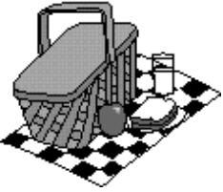
Pick one part from each of the following three questions, and make the best possible estimate for the situation. Your answer will be a combination of several quantities. Be sure to specify what assumptions you have made in arriving at your estimate.
1. a. How long would it take you to eat your weight in food?
or
b. What is the weight of all the trash produced in your house in a year?
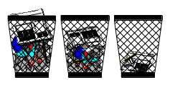
Assumptions:
Calculation:
2. a. How many hot dogs are sold in a baseball season at Fenway Park?
or
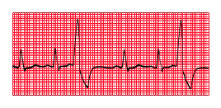
b. How many times does a person’s heart beat in a lifetime?

Assumptions:
Calculation:
3. a. What is the volume of gasoline your car uses in a year? How does this compare to the volume of liquid (water, soda, coffee, etc.) you drink in a year?
or

b. What is the volume occupied by one million dollars in single dollar bills? How does this volume compare to your own body's volume?

Assumptions:
Calculation:

